Chapter 4
Specific Factors and Income Distribution

■ Chapter Organization
The Specific Factors Model.
Box: What Is a Specific Factor?
Assumptions of the Model.
Production Possibilities.
Prices, Wages, and Labor Allocation.
Relative Prices and the Distribution of Income
International Trade in the Specific Factors Model.
Income Distribution and the Gains from Trade.
The Political Economy of Trade: A Preliminary View.
The Politics of Trade Protection
Trade and Unemployment
Case Study: U.S. Manufacturing Employment and Chinese Import Competition
Box: The Trump Trade War
International Labor Mobility.
Case Study: Wage Convergence in the European Union.
Case Study: Immigration and the U.S. Economy.

Summary
APPENDIX TO CHAPTER 4: Further Details on Specific Factors.
Marginal and Total Product
Relative Prices and the Distribution of Income

■ Chapter Overview
In Chapter 3, the Ricardian model of trade was introduced with labor as the single factor of production exhibiting constant returns to scale. Although informative, this model fails to highlight the observed opposition to free trade. In this chapter, the Specific Factors model is presented to gain a better understanding of the distributional effects of trade. After trade, the exporting industry expands, while the import competing industry shrinks. As a result, the factor specific to the exporting industry gains from trade, while the factor specific to the import competing industry loses from trade. However, the aggregate gains from trade are greater than the losses.
The Specific Factors model assumes that there is one factor that is mobile between sectors (commonly thought of as labor) and production factors that are specific to each sector. The chapter begins with a simple economy producing two goods: cloth and food. Cloth is produced using labor and its specific factor, capital. Food is produced using labor and its specific factor, land. Given that capital and labor are specific to their respective industries, the mix of goods produced by a country is determined by share of labor employed in each industry. The key difference between the Ricardian model and the Specific Factors model is that in the latter, there are diminishing returns to labor. For example, production of food will increase as labor is added, but given a fixed amount of land, each additional worker will add less and less to food production.
As we assume that labor is perfectly mobile between industries, the wage rate must be identical between industries. With competitive labor markets, the wage must be equal to the price of each good times the marginal product of labor in that sector. We can use the common wage rate to show that the economy will produce a mix of goods such that the relative price of one good in terms of the other is equal to the relative cost of that good in terms of the other. Thus, an increase in the relative price of one good will cause the economy to shift its production toward that good.
With international trade, the country will export the good whose relative price is below the world relative price. The world relative price may differ from the domestic price before trade for two reasons. First, as in the Ricardian model, countries differ in their production technologies. Second, countries differ in terms of their endowments of the factors specific to each industry. After trade, the domestic relative price will equal the world relative price. As a result, the relative price in the exporting sector will rise, and the relative price in the import competing sector will fall. This will lead to an expansion in the export sector and a contraction of the import competing sector.
Suppose that after trade, the relative price of cloth increases by 10%. As a result, the country will increase production of cloth. This will lead to a less than 10% increase in the wage rate because some workers will move from the food to the cloth industry. The real wage paid to workers in terms of cloth (w/P_{C}) will fall, while the real wage paid in terms of food (w/P_{F}) will rise. The net welfare effect for labor is ambiguous and depends on relative preferences for cloth and food. Owners of capital will unambiguously gain because they pay their workers a lower real wage, while owners of land will unambiguously lose as they now face higher costs. Thus, trade benefits the factor specific to the exporting sector, hurts the factor specific to the import competing sector, and has ambiguous effects on the mobile factor. Despite these asymmetric effects of trade, the overall effect of trade is a net gain. Stated differently, it is theoretically possible to redistribute the gains from trade to those who were hurt by trade and make everyone better off than they were before trade.
Given these positive net welfare effects, why is there such opposition to free trade? To answer this question, the chapter looks at the political economy of protectionism. The basic intuition is that the though the total gains exceed the losses from trade, the losses from trade tend to be concentrated, while the gains are diffused. Import tariffs on sugar in the United States are used to illustrate this dynamic. It is estimated that sugar tariffs cost consumers $3.5 billion in 2015, representing $30 per household in the U.S. While the aggregate loss is significant, the individual losses are spread out to the point where they are not large enough to induce people to lobby for an end to these tariffs. However, the gains from protectionism are concentrated among a small number of sugar producers, who are able to effectively coordinate and lobby for continued protection. When the losses from trade are concentrated among politically influential groups, import tariffs are likely to be seen.
Although the losers from trade are often able to successfully lobby for protectionism, the chapter highlights three reasons why this is an inefficient method of limiting the losses from trade. First, the actual impact of trade on unemployment is fairly low, with estimates of only 2.5% of unemployment directly attributable to international trade. This fact is highlighted in a case study on the decline in U.S. manufacturing employment, which is often blamed on competition from China. Manufacturing employment in the U.S. had been on a downward trend long before trade with China took off in the mid-1990s. In fact, the trend in manufacturing employment in the U.S. is relatively unaffected by trade with China, suggesting that factors other than trade (at least with China) are responsible. Second, the losses from trade are driven by one industry expanding at the expense of another. This phenomenon is not specific to international trade and is also seen with changing preferences or new technology. Why should policy be singled out to protect people hurt by trade and not for those hurt by these other trends? Finally, it is more efficient to help those hurt by trade—by redistributing the gains from trade in the form of safety nets for those temporarily unemployed and worker retraining programs to ease the transition from import competing to export sectors—than it is to limit trade to protect existing jobs. This is illustrated by the employment effects of tariffs imposed by the Trump administration. While American firms and workers in protected industries like steel and aluminum were helped by these tariffs, downstream industries using protected inputs and industries suffering from retaliatory tariffs imposed by other countries were hurt. The empirical evidence suggests that the negative employment effects in downstream and exporting industries were significantly higher than the gains in protected industries. For example, employment in downstream industries is about 80 times higher than that in primary industries like aluminum and steel. Retaliatory tariffs were estimated to lead to three times as many job losses as jobs gained from the Trump administration’s initial tariffs.
Finally, the chapter uses the framework of the Specific Factors model to analyze the distributional effects of international labor migration. With free migration of labor across borders, wages must equalize among countries. Workers will migrate from low-wage countries to high-wage countries. As a result, wages in the low-wage countries will rise, and those in the high-wage countries will fall. Though the net effect of free migration is positive, there will be both winners and losers from migration. Workers who stayed behind in the low-wage country will benefit, as will owners of capital in the high-wage country. Workers in the high-wage country will be hurt, as will owners of capital in the low-wage country. We also need to consider the education levels of migrants relative to the country they move to. Immigrants to the United States, for example, tend to be concentrated in the lowest educational groups. Thus, migration is likely to only have negative effects on the wages of the least educated Americans while raising the wages of those with more education.

■ Answers to Textbook Problems

1. Texas and Louisiana are both oil-producing states. A decrease in the price of oil will reduce output in these two states, hurting owners of capital and workers in the oil industry. Although some capital will be able to migrate to other sectors (for example, those that use oil as a factor of production), a significant fraction of capital is specific to the oil industry. By that same token, some workers in the oil industry have skills that transfer to other sectors, and this transition will take time and is not costless.
2. a.

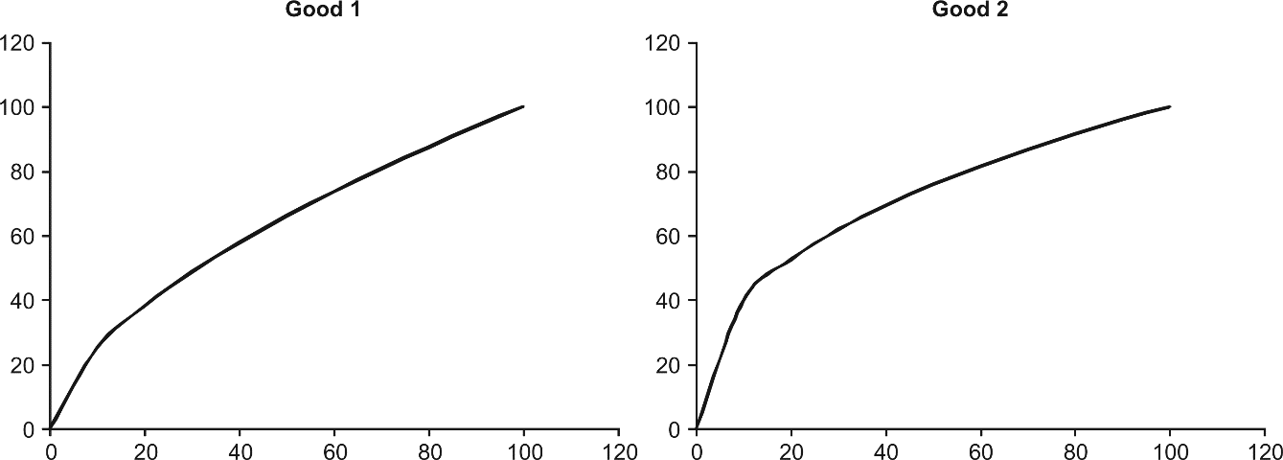
b.
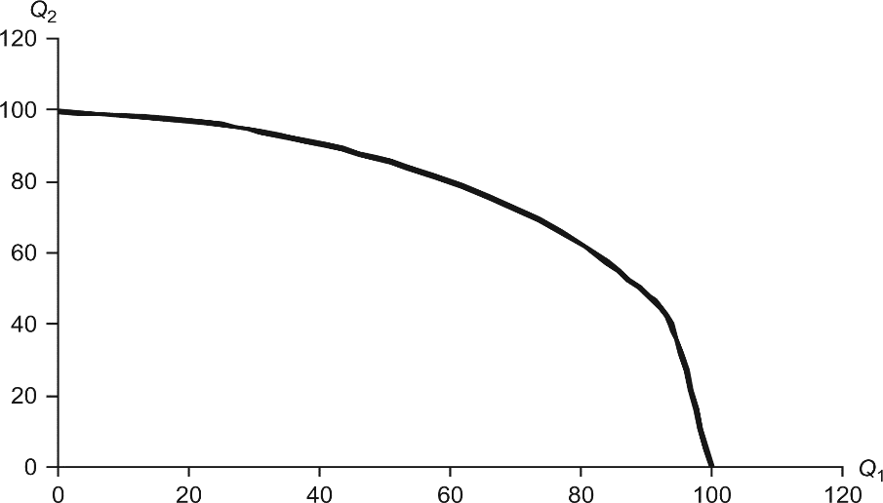
The curve in the PPF reflects diminishing returns to labor. As production of Q₁ increases, the opportunity cost of producing an additional unit of Q₁ will rise. Basically, as you increase the number of workers producing Q₁ with a fixed supply of capital, each additional worker will contribute less to the production of Q₁ and represents an increasingly large loss of potential production of Q₂.
3. a. Draw the marginal product of labor times the price for each sector given that the total labor allocated between these sectors must sum to 100. Thus, if there are 10 workers employed in Sector 1, then there are 90 workers employed in Sector 2. If there are 50 workers employed in Sector 1, then there are 50 workers employed in Sector 2. For simplicity, define P₁ = 1 and P₂ = 2 (it does not matter what the actual prices are in determining the allocation of labor, only that the relative price P₂/P₁ = 2).
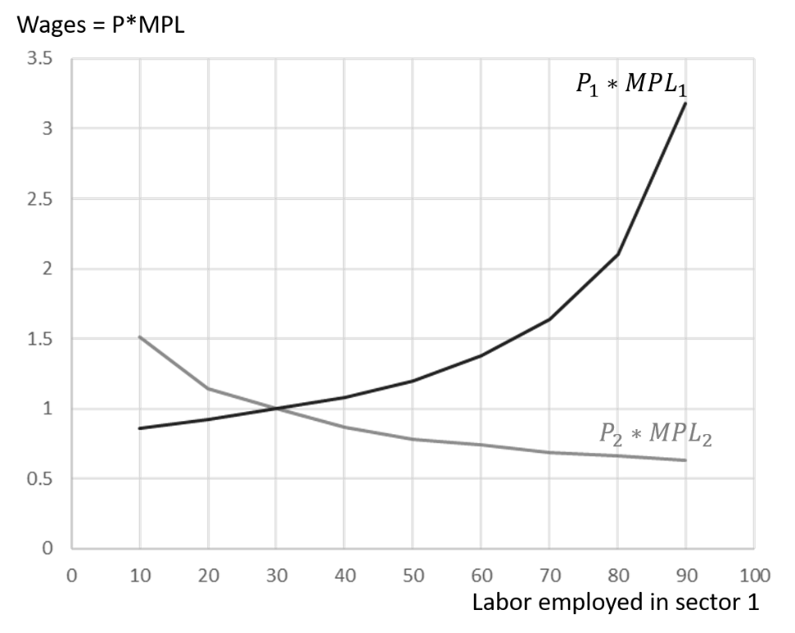

In competitive labor markets, the wage is equal to price times the marginal product of labor. With mobile labor between sectors, the wage rate must be equal between sectors. Thus, the equilibrium wage is determined by the intersection of the two P × MPL curves. Looking at the diagram above, it appears that this occurs at a wage rate of 1 and a labor supply of 30 workers in Sector 1 (70 workers in Sector 2).
b. From part (a), we know that 30 units of labor are employed in Sector 1 and 70 units of labor are employed in Sector 2. Looking at the table in Question 2, we see that these labor allocations will produce 48.6 units of good 1 and 86.7 units of good 2.
At this production point (Q₁ = 48.6, Q₂ = 86.7), the slope of the PPF must be equal to −P₁/P₂, which is −½. Looking at the PPF in Question 2a, we see that it is roughly equal to −½.
c. If the relative price of good 2 falls to 1.3, we simply need to redraw the P × MPL diagram with P₁ = 1 and P₂ = 1.3.
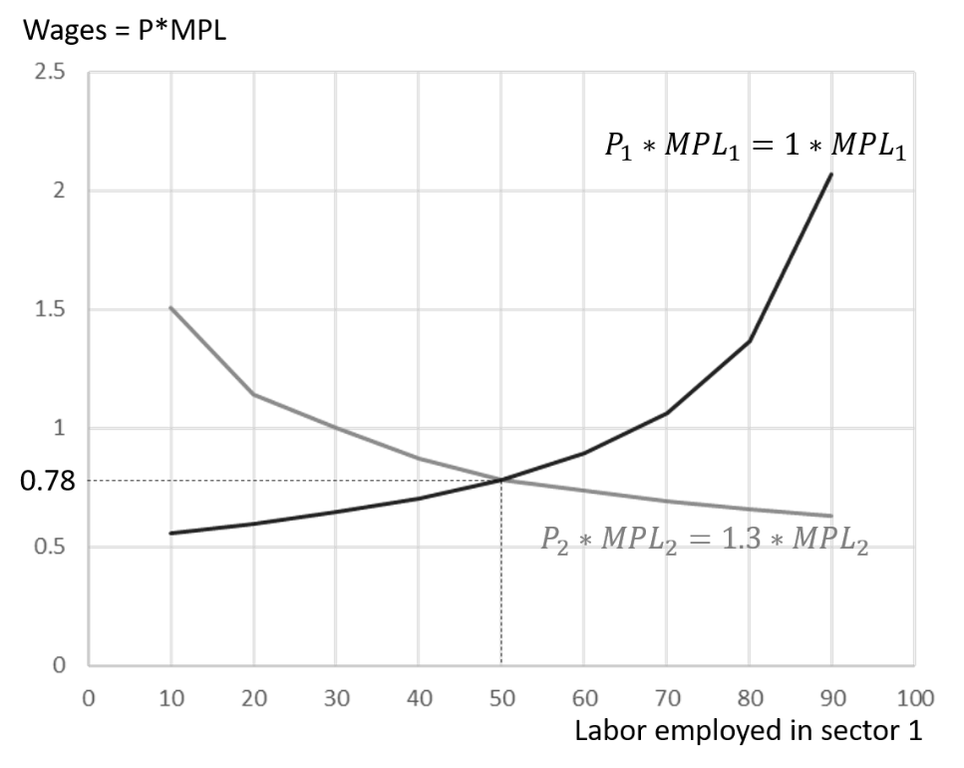

The decrease in the price of good 2 leads to an increase in the share of labor accruing to Sector 1. Now, the two sectors have equal wages (P × MPL) when there are 50 workers employed in both sectors.
Looking at the table in Question 2, we see that with 50 workers employed in both Sectors 1 and 2, there will be production of Q₁ = 66 and Q₂ = 75.8.
The PPF at the production point Q₁ = 66, Q₂ = 75.78 must have a slope of -P₁/P₂ = −1/1.3 = −0.77.
d. The decrease in the relative price of good 2 led to an increase in production of good 1 and a decrease in the production of good 2. The expansion of Sector 1 increases the income of the factor specific to Sector 1 (capital). The contraction of Sector 2 decreases the income of the factor specific to Sector 2 (land).
4. a. The increase in the capital stock in Home will increase the possible production of good 1, but have no effect on the production of good 2 because good 2 does not use capital in production. As a result, the PPF shifts out to the right, representing the greater quantity of good 1 that Home can now produce.

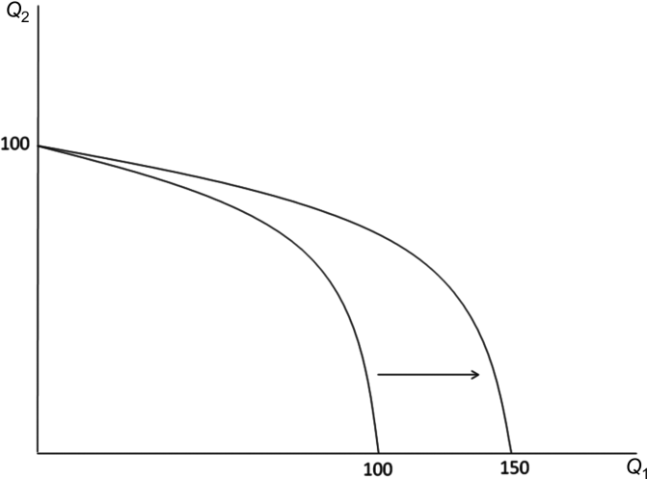
b. Given the increased production possibility for Home, the relative supply of home (defined as Q₁/Q₂) is further to the right than the relative supply for Foreign. As a result, the relative price of good 1 is lower in Home than it is in Foreign.
c. If both countries open to trade, Home will export good 1, and Foreign will export good 2.
d. Owners of capital in Home and owners of land in Foreign will benefit from trade, while owners of land in Home and owners of capital in Foreign will be hurt. The effects on labor will be ambiguous because the real wage in terms of good 1 will fall (rise) in Home (Foreign) and the real wage in terms of good 2 will rise (fall) in Home (Foreign). The net welfare effect for labor will depend on preferences in each country. For example, if labor in Home consumes relatively more of good 2, they will gain from trade. If labor in Home consumes relatively more of good 1, they will lose from trade.
5. The real wage in Home is 10, while real wage in Foreign is 18. If there is free movement of labor, then workers will migrate from Home to Foreign until the real wage is equal in each country. If 4 workers move from Home to Foreign, then there will be 7 workers employed in each country, earning a real wage of 14 in each country.
We can find total production by adding up the marginal product of each worker. After trade, total production is 20 + 19 + 18 + 17 + 16 + 15 + 14 = 119 in each country for total world production of 238. Before trade, production in Home was 20 + 19 + 18 = 57. Production in Foreign was 20 + 19 + … + 10 = 165. Total world production before trade was 57 + 165 = 222. Thus, trade and migration increased total output by 16.
Workers in Home benefit from migration, while workers in Foreign are hurt. Landowners in Home are hurt by migration (their costs rise), while landowners in Foreign benefit.
  - If only 2 workers can move from Home to Foreign, there will be a real wage of 12 in Home and a real wage of 16 in Foreign.
a. Workers in Foreign are hurt as their wage falls from 18 to 16.
b. Landowners in Foreign benefit as their costs fall by 2 for each worker employed.
c. Workers who stay at home benefit as their wage rises from 10 to 12.
d. Landowners in Home are hurt as their costs rise by 2 for each worker employed.
e. The workers who do move benefit by seeing their wages rise from 10 to 16.
  - By restricting immigration, the drop in wages in the high-wage country is not as high as it would have been had migration been open. By the same token, the increase in wages in the low-wage country is not as large as it would have been with open migration. Thus, migration restrictions increase the net gain from migrating to those lucky few who are able to move. We see this illustrated in questions 5 and 6. With open borders (question 5), migrants from Home increased their real wages from 10 to 14 by migrating to Foreign. With restricted immigration (question 6), migrants from Home increased their real wages from 10 to 16 by migrating to foreign. Though there are fewer migrants in the latter scenario, those who do migrate end up better off.

